# Neural Network Hw1 Report

1.

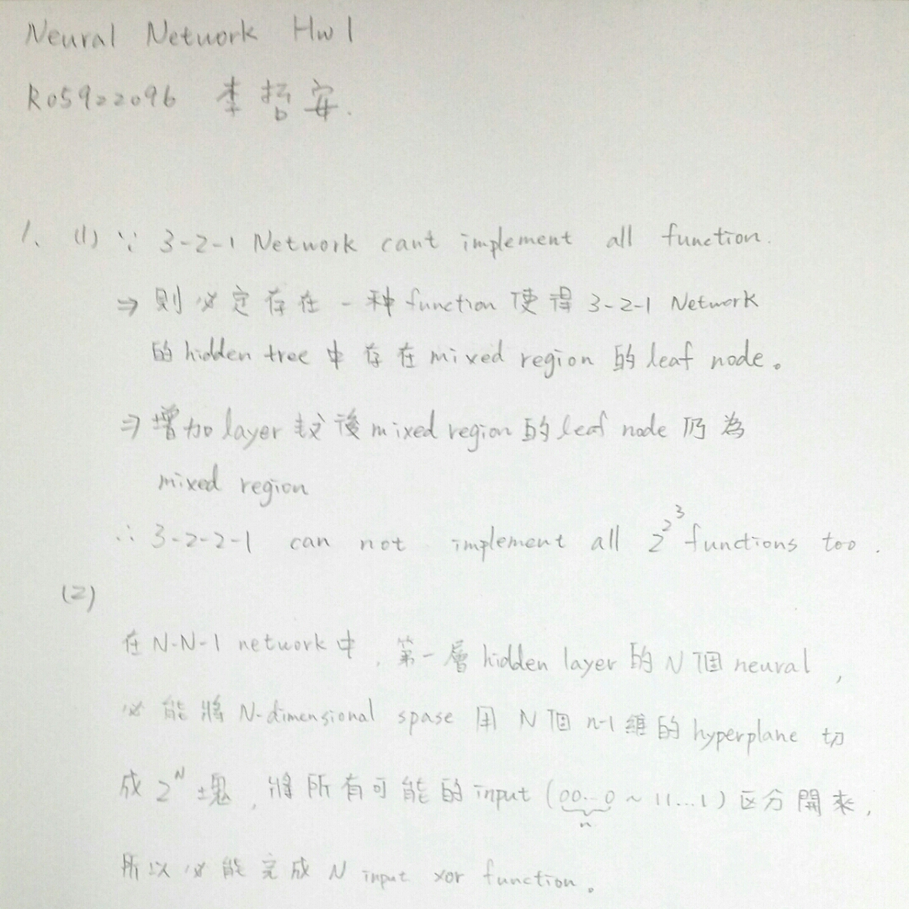

2.

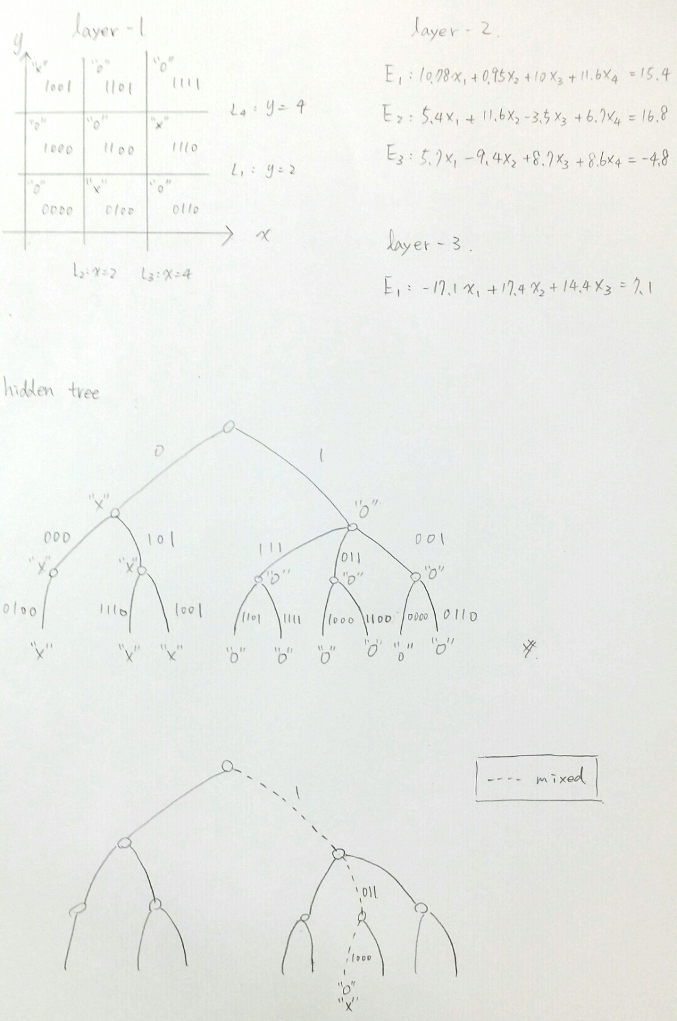

3.

BPN source code in folder “BackPropogationNN”

BPN executable file in folder “ExecutableJAR”

2-4-3-1 network

error curve

first layer result

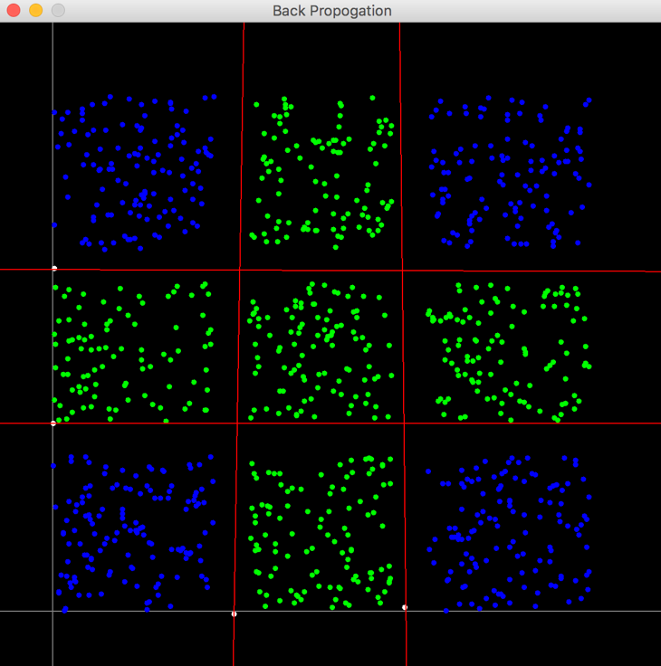

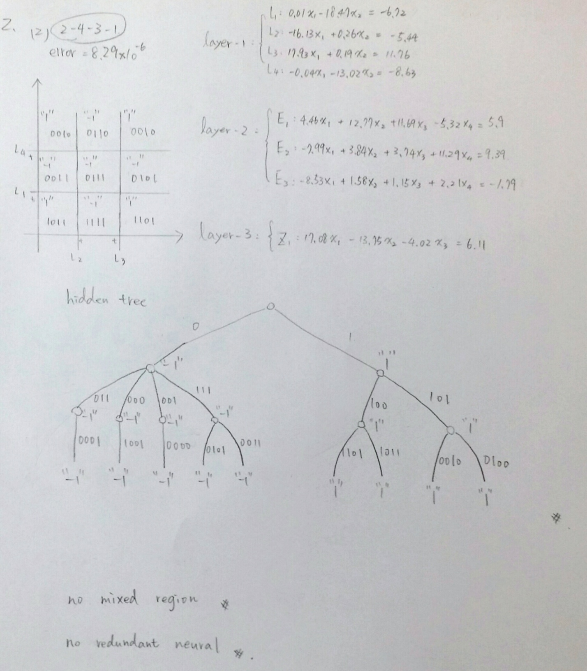

2-8-6-1 network

error curve

first layer result

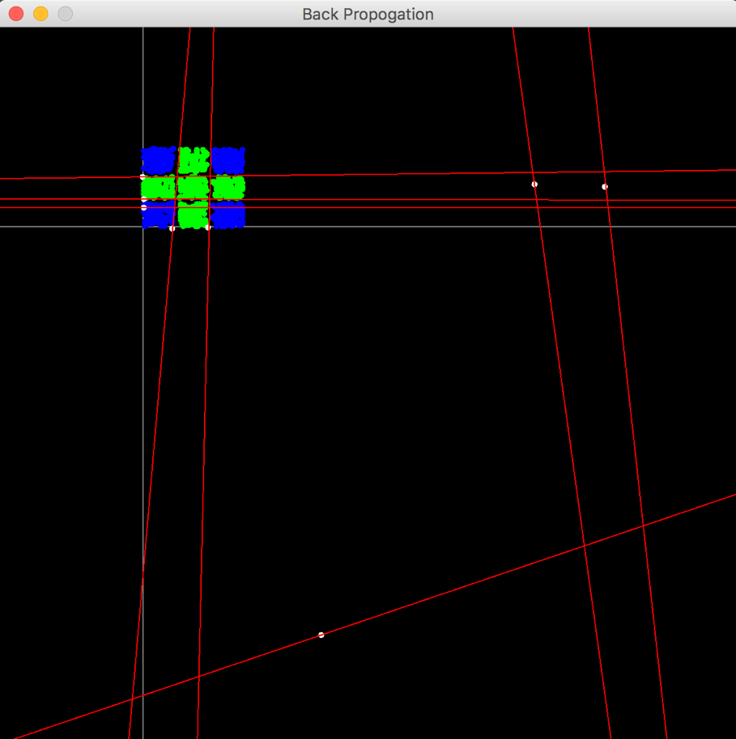

weight

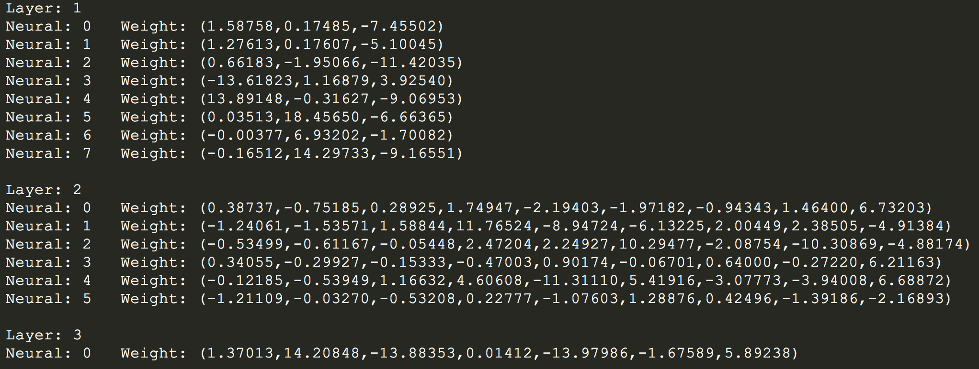

hidden tree

../ResultData/2-8-6-1_hiddenTree.png

No mixed region.

In first hidden layer, “1-th”, “2-th” and “3-th” nuerals are redundant.

In second hidden layer, “1-th” and “6-th” nuerals are redundant.

Compare the error curve we can find that the error in “2-8-6-1 network” was

decrease faster than the error in “2-4-3-1 network”.